PRINCIPAL’S COMMENTS
Once again I am amazed at how quickly the first third of the school year has gone. A reminder to everyone that student reporting changed last year and formal reports will not come out in December. Instead, over the past month, and in coming months, teachers will be providing ongoing communication of your child’s learning. This communication may come home as a hard copy ‘evidence of learning’, through email, or through FreshGrade. Please take the time to reflect on these communications with your child and discuss their growth and learning. In February, a mid-year progress report will come home with each child as well.

The month coming up is certainly a busy one. December is always an exciting time with lots of special events and activities in the classroom and at home. Sometimes the ‘busyness of the season’ can become overwhelming, here are a few tips that may help children cope with all the ‘extras’:

- try to stick with a regular bedtime and routine
at bedtime as much as possible, children still need their sleep, especially at this time of year
- maintain routines for homework and reading
time as routines help to keep structure to the day
- ensure children get lots of healthy, nutritious
food throughout the day (to balance out the extra treats that tend to be abundant at this time of year)
- take time to get a bit of exercise, go for a walk
or a swim, as exercise can reduce stress for everyone
- ask children how they are doing, they can often
tell us when it is getting too busy

We do have a few ‘festive events’ planned here at school also so please check your child’s planner regularly for notices and information. It is a busy season; we hope to make it fun and enjoyable too!

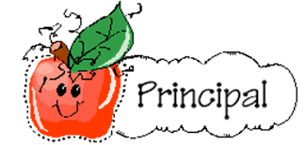
Looking forward to a great December,

Yours in education,
Mrs. Jacquie Poulin

CHRISTMAS/HOLIDAY CONCERT

Rehearsals for our holiday concert are going very well. The students and staff are excited to show off all their hard work on Thursday, December 14th at both a 1:00 pm and a 6:30 pm show. As was mentioned in the notice sent home last week, if any parents, grandparents, or extended family are able to attend the 1:00 pm show instead of the 6:30 pm that would be great as the evening show will surely be a very packed house. But please remember, we do need all students back for the evening show as all our rehearsals are done with the full classes. Also, please be watching for additional notices and emails regarding other important information such as costumes as some classes may be having some theme to their song.

INCLEMENT WEATHER – DRESSING APPROPRIATELY

Please ensure that your child has a warm coat, mittens or gloves, boots, and a hat at school. We know that those December winds can come in from the North and make recess a little chilly. Also, we do live in a very wet climate and certainly cannot stay in every time it is a bit drizzly so please ensure students have gear that is good for going out in the rain. Thanks for your help with this matter.

PAC MEETINGS
These monthly meetings are open to all our parents of the Frank Ney School community. It is an excellent opportunity to provide your input and suggestions on matters concerning educational issues and provide support to the programs and activities at the school. December’s meeting is on Tuesday, December 12th at 6:00 pm. For this month only, child minding will not be available as the meeting will be a social.

TRAFFIC SAFETY-PARKING LOT

Anyone driving children to Frank Ney is well aware of our daily traffic challenges. Drivers are urged to exercise extreme caution at all times in the parking lot as well as the drop off/pick up area. Congestion at peak times (arrival, dismissal) means there are many children out and about. Please be extra vigilant when pulling in, backing out or driving through. We have many new youngsters and families using our parking lot this year. This is becoming a major issue both in front of the school and in the parking lot. Please do not park a vehicle in the drop off area, cars should not be in this area for more than a quick drop off or pick up. No vehicles should be in the drop off/pick up area without a driver in the vehicle, please do not park your vehicle and leave it in this area before school or after school.

SCHOOL CLOSURE REMINDER
It is that time of year again, when the school district would like to remind parents about school closure procedures. The most common reasons that schools might be closed are dangerous road conditions due to a heavy snowfall or ice.

If you are wondering if schools are open on a particular day, for the most current updates listen to local radio stations (WAVE 102.3 FM and WOLF 106.9 FM) in the mornings.

We also attempt to put an announcement of any school closures on the school district website, www.sd68.bc.ca, and on Twitter and Facebook, but our ability to do so could be affected by such things as power outages and technical issues. If there is no announcement on the website or social media, please be sure to listen to local radio stations.

We would like to remind parents that it is their right to make the final decision as to whether it is safe for their children to travel to school on any given day. While the district strives to make the best decision possible for students across the district, there may be circumstances in your neighbourhood that lead you to decide to keep your children home, even though schools are open.

EXTRACURRICULAR EXPECTATIONS
The guidelines/expectations outlined below serve to enhance our extracurricular program in terms of student commitment, academic and behavioural expectations, student conduct in various social settings and positive peer relationships. Our goal for all students is to maximize participation, exercise fair play and contribute to the team in a positive manner.

- A student must observe all expectations set down by the coach/sponsor. Repeated infractions relative to expectations will result in a student being dismissed from the activity/event.

- Attendance at all practice sessions is mandatory
unless the student has a valid reason for his/her absence.

- A student must attend classes on days when
practice or games are scheduled unless there are extenuating circumstances. Illness shall be reported to school office and coach/sponsor by telephone.


- A student who fails
to keep up with his/her academic expectations e.g. assignments, homework, or disobeys both classroom and school rules, may not be able to participate in any extracurricular activity until the classroom teacher grants permission.

- A student suspended from school or having a
detention may not participate in any extracurricular activity until the disciplinary period is lifted.

- Students are expected to meet the established
‘Code of Conduct’ in all extracurricular activities. Failure to meet these expectations may result in disciplinary action in consultation with parents/guardians.


VOLLEYBALL
We have moved right into our next extra-curricular season – volleyball. We have all four teams this year and are looking forward to a great season. All parent drivers please remember to get their criminal record checks. Good luck to all the teams.

Many thanks to the coaches for working with these teams this volleyball season. Good luck with your season!

LATES

A reminder to all families - to promote responsibility and a value for education, we will be encouraging students to arrive to class on time. When students are late, they often miss information given first thing in the morning, basic directions on a task, and disrupt the learning environment of the rest of the class. Sometimes students are late due to medical, dental or other appointments, these are the exceptions and we understand they will occur.

Thank you in advance for your support with helping us develop responsible student citizens at Frank Ney Elementary School.

ARTISTS IN THE CLASSROOM
This fall Nanaimo Art Gallery visited the school with their TD Artists in the School Program and inspired the students with art. Frank J Ney Elementary School welcomed artists Anne Marie Veale, Sean Gallagher, Kaylea Reeve, Arlene Deptuck and Lee Stead for 13 sessions including Pinch Coil Pots, Colour Theory, Sticker Printing, Face Mugs, Hammertime and Star Santas. Students experienced hands-on sculpture, pottery, printmaking, Indigenous Language leather bracelets, painting and more. For more information please visit nanaimoartgallery.ca

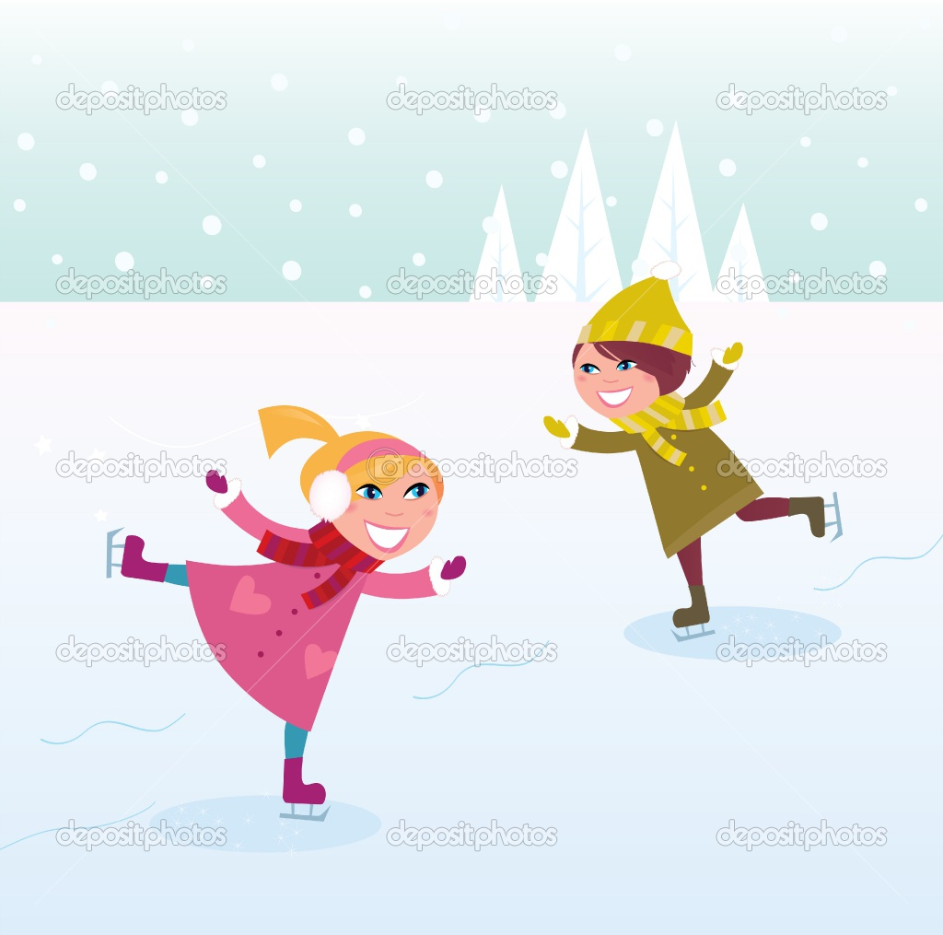

DATES TO REMEMBER:

December
Mon., Dec. 4 PAC Hot Lunch day
Mon., Dec. 11 PAC Popcorn day
Tues., Dec. 12 PAC mtg. – 6:00 pm – Pipers Pub
Thurs., Dec. 14 Christmas Concert – 1:00pm & 6:30pm
Fri., Dec. 22 Last day before the Winter Break

School re-opens Monday, January 8th, 2018

January
Mon., Jan. 8 First day back – welcome back!
Tues, Jan. 16 PAC mtg – 6:00 pm – Library



